

CONSENT CERTIFICATE

PLEASE PRINT
To: The Scouters of Eastrand District.

I, (Full name of legal Guardian) __________________________________________
Of (Address) __________________________________________________________
__________________________________________________ Postal Code _______
Tel No: (_____) _________________ Cell No: ____________________________
being the Legal Guardian of (Ward's full name) _____________________________
hereby make formal application for my ward to take part in the activities connected with the BP day and Swimming Gala held at Boksburg High School from 21/02/2010.
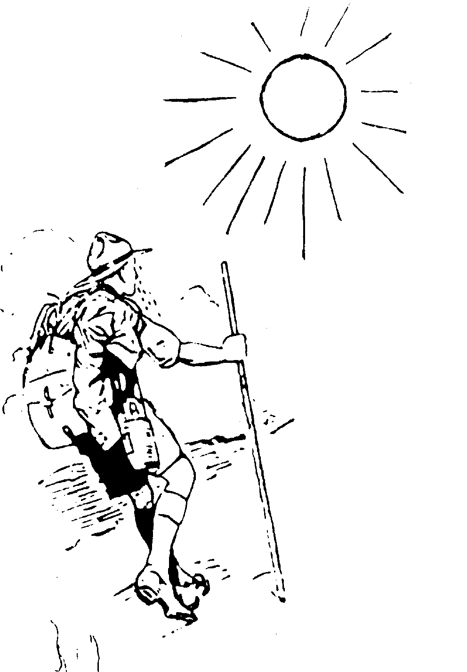
I hereby appoint and authorize the Scouter in charge to act in my place as guardian with full authority to consent to my ward undergoing surgical or other medical treatment. I undertake to pay the cost of such treatment.

I fully understand and accept that all activities are undertaken at my ward’s own risk.


I am aware that neither the South African Scout Association nor its Scouters accept responsibility for any loss, injury or damage that the person or property of my ward may sustain whilst engaged in any Scouting activity and I waive any right that I or my ward may have to claim compensation against the South African Scout Association or any of its Scouters or other members in respect of loss, injury or damage incurred whilst engaged in any Scouting activity howsoever arising and I indemnify them against all claims.

Signed: ______________________
(Legal Guardian)

Witness: _____________________
(Not Spouse)

Date: ________day of __________________ 2010.

HEALTH CERTIFICATE
PLEASE PRINT

I certify that, to the best of my knowledge, my ward _______________________

- Is not suffering from any physical disability or illness which makes it inadvisable to attend Camp, but I wish to draw your attention to the following :- ____________________________________________________________________________________________________________________________________

- Is not suffering from an infectious disease, and has not been in contact with anyone so suffering during the past 14 days. __________________________________________________________________
__________________________________________________________________

- I do/do not give my permission for him to take part in any swimming activities.

- Name of Medical Aid: _______________________________________________

Member’s Medical Aid Number: _______________________________________

Name of Member: __________________________________________________

Id Number of Member: ______________________________________________

- Name of Doctor: ________________ Doctor’s phone number: ____________

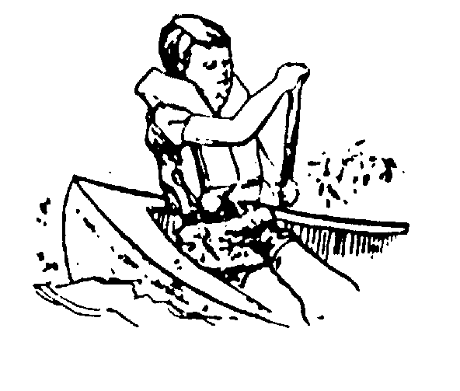

Signed: ___________________________________
(Legal Guardian)

Telephone: (H) _____________________________
(W) _____________________________
(Cell) ____________________________

Dated this ______day of _________________2010.

